EX NO : 1  DATE : 12-06-26 | DATA ENGINEERING

AIM:
Understanding and Exploring Different Types of Data
PROBLEM STATEMENT:
You have been provided with three datasets:
1. Student performance data (CSV file) - Contains demographic, social, family, and academic information of students. Used to analyze factors affecting student performance and predict final grades.
Rows - 395 and Columns - 33
https://www.kaggle.com/datasets/devansodariya/student-performance-data
2. Movie reviews (Text file) - Contains movie reviews collected from IMDb along with sentiment labels (positive/negative). Used for sentiment analysis and text mining tasks.
Rows - 50000 and Columns - 2
https://www.kaggle.com/datasets/lakshmi25npathi/imdb-dataset-of-50k-movie-
reviews
3. Image dataset - A collection of small color images belonging to 10 different classes such as airplane, automobile, bird, cat, deer, dog, frog, horse, ship, and truck. Used for image classification and computer vision tasks.
Images - 60000
https://www.cs.toronto.edu/~kriz/cifar.html

Perform exploratory analysis on each dataset and identify its characteristics.
PART A – TABULAR DATA
Using the student performance dataset:
1. Load the dataset.
2. Display the first 10 records.
3. Identify the number of rows and columns.
4. List all attributes.
5. Check for missing values.
6. Compute basic statistics such as mean, median, minimum, and maximum marks.
7. Identify numerical and categorical attributes.
8. Draw a histogram of marks.
9. Find correlation between numerical attributes.
10. Identify possible target variables for prediction.

CODE:
# 1. Load the dataset
import pandas as pd
import matplotlib.pyplot as plt
import seaborn as sns
df = pd.read_csv(r"D:\SEM_5\ML\datasets\Table_data\student_data.csv")

# 2. Display the first 10 records
print("First 10 Records:")
print(df.head(10))

# 3. Number of rows and columns
rows, cols = df.shape
print("\nNumber of Rows:", rows)
print("Number of Columns:", cols)

# 4. List all attributes
print("\nAttributes (Columns):")
print(df.columns.tolist())

# 5. Check for missing values
print("\nMissing Values:")
print(df.isnull().sum())
# Total missing values
print("\nTotal Missing Values:", df.isnull().sum().sum())

# 6. Basic Statistics for Marks Column (G3)
print("\nBasic Statistics for Marks (G3):")
print("Mean Marks:", df['G3'].mean())
print("Median Marks:", df['G3'].median())
print("Minimum Marks:", df['G3'].min())
print("Maximum Marks:", df['G3'].max())

# 7. Identify Numerical and Categorical Attributes
numerical_cols = df.select_dtypes(include=['int64', 'float64']).columns
categorical_cols = df.select_dtypes(include=['object']).columns
print("\nNumerical Attributes:")
print(list(numerical_cols))
print("\nCategorical Attributes:")
print(list(categorical_cols))

# 8. Draw Histogram of Marks
if 'G3' in df.columns:
plt.figure(figsize=(8,5))
plt.hist(df['G3'], bins=10)
plt.title("Histogram of Final Grade (G3)")
plt.xlabel("G3 Marks")
plt.ylabel("Frequency")
plt.grid(True)
plt.show()
else:
print("\nColumn 'G3' not found. Use the appropriate marks column.")

# 9. Correlation Between Numerical Attributes
correlation_matrix = df[numerical_cols].corr()
print("\nCorrelation Matrix:")
print(correlation_matrix)

# 10. Possible Target Variables for Prediction
print("\nPossible Target Variables:")
possible_targets = []
for col in ['G1', 'G2', 'G3']:
if col in df.columns:
possible_targets.append(col)
print(possible_targets)

OUTPUT:
2.
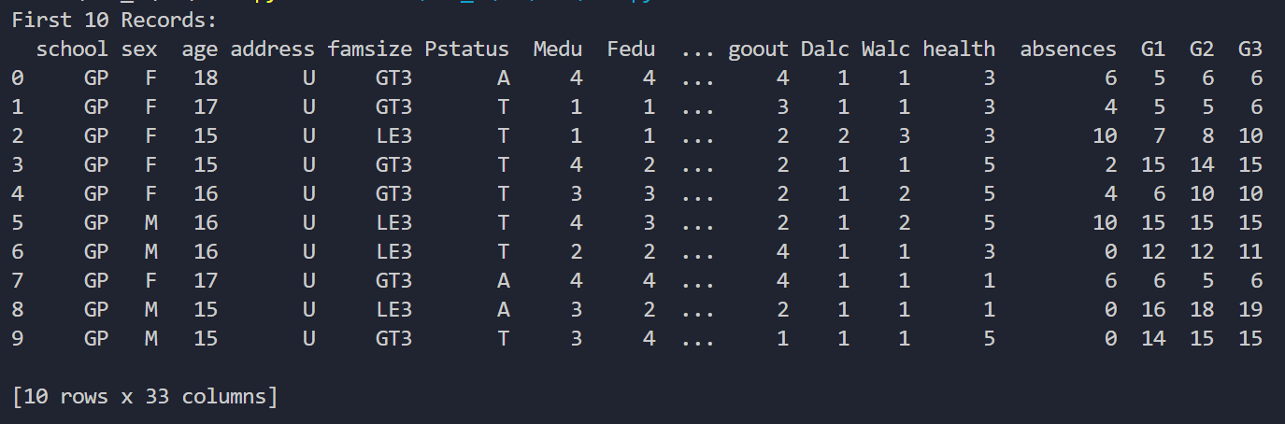
3.
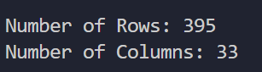

4.
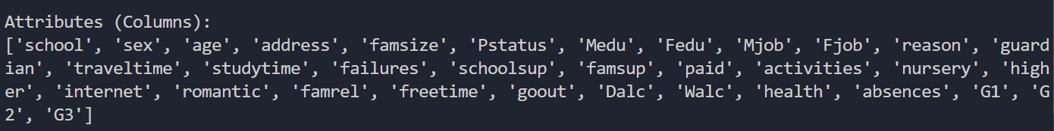

5.
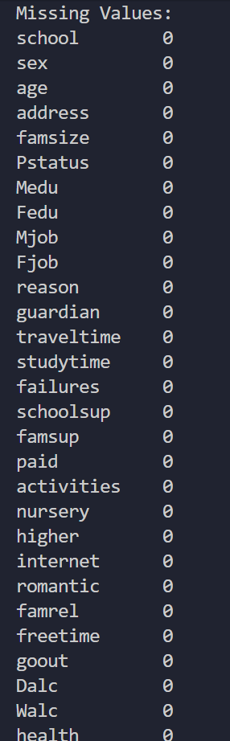
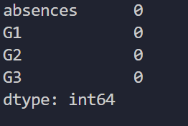
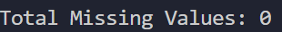
6.
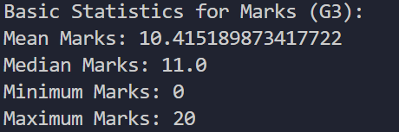

7.
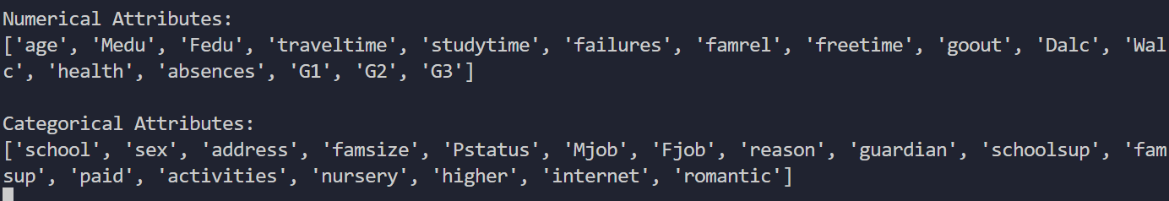

8.
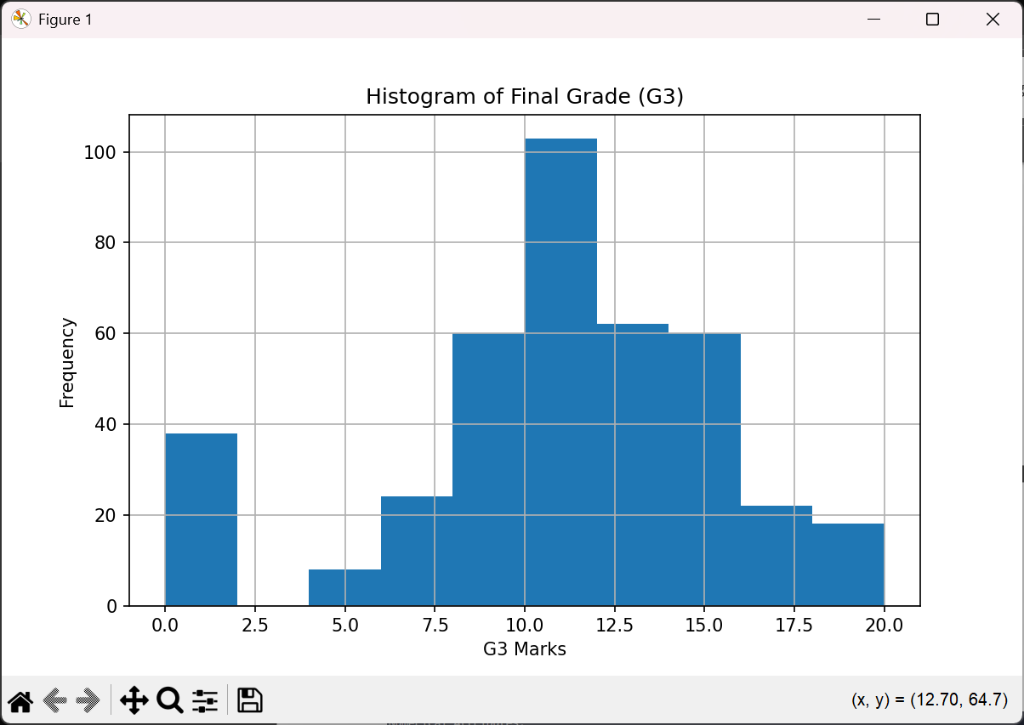

9.
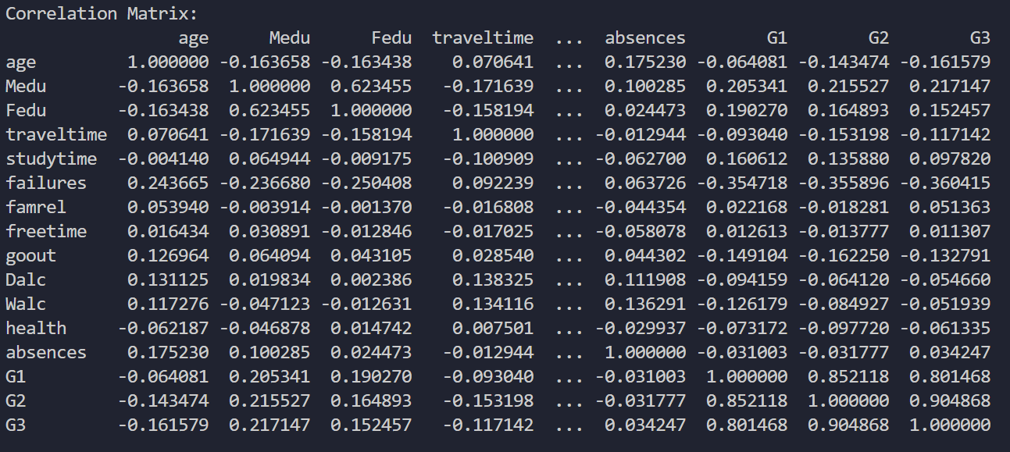
10.
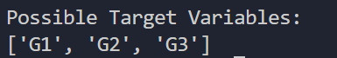

PART B – TEXT DATA
Using the feedback dataset:
1. Read the text file.
2. Count the number of sentences.
3. Count the number of words.
4. Find the 10 most frequently occurring words.
5. Remove common stop words and compare the results.
ADDITIONAL TEXT ANALYTICS TASK
6. Calculate vocabulary size.
7. Find average sentence length.
8. Generate a word cloud.

CODE:
import pandas as pd
import nltk
from nltk.corpus import stopwords
from nltk.tokenize import sent_tokenize, word_tokenize
from collections import Counter
from wordcloud import WordCloud
import matplotlib.pyplot as plt

# 1. Read the dataset
df = pd.read_csv(r"D:\SEM_5\ML\datasets\Text_data\IMDB Dataset.csv")
reviews = df['review']
text = " ".join(reviews.astype(str))

# 2. Count the number of sentences
sentences = sent_tokenize(text)
print("\nNumber of Sentences:")
print(len(sentences))
# 3. Count the number of words
words = word_tokenize(text)
words = [word.lower() for word in words if word.isalpha()]
print("\nNumber of Words:")
print(len(words))

# 4. Find the 10 most frequent words
word_freq = Counter(words)
print("\nTop 10 Most Frequent Words:")
for word, count in word_freq.most_common(10):
print(f"{word} : {count}")

# 5. Remove stop words and compare results
stop_words = set(stopwords.words('english'))
filtered_words = [word for word in words
if word not in stop_words]
filtered_freq = Counter(filtered_words)
print("\nTop 10 Words After Removing Stop Words:")
for word, count in filtered_freq.most_common(10):
print(f"{word} : {count}")

# 6. Calculate Vocabulary Size
vocabulary = set(filtered_words)
print("\nVocabulary Size:")
print(len(vocabulary))

# 7. Find Average Sentence Length
total_words = len(words)
total_sentences = len(sentences)
avg_sentence_length = total_words / total_sentences
print("\nAverage Sentence Length:")
print(round(avg_sentence_length, 2), "words")

# 8. Generate Word Cloud
wordcloud = WordCloud(
width=1000,
height=500,
background_color='white'
).generate(" ".join(filtered_words))
plt.figure(figsize=(12, 6))
plt.imshow(wordcloud, interpolation='bilinear')
plt.axis("off")
plt.title("Word Cloud of IMDb Reviews")
plt.show()

OUTPUT:
2.
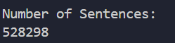

3.
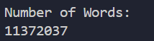

4.
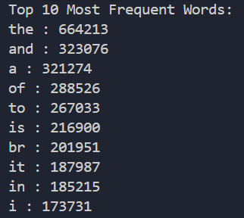

5.
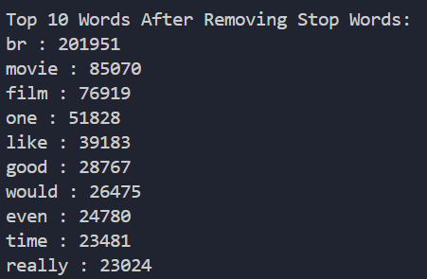

6.
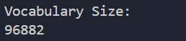

7.
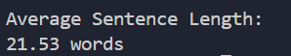

8.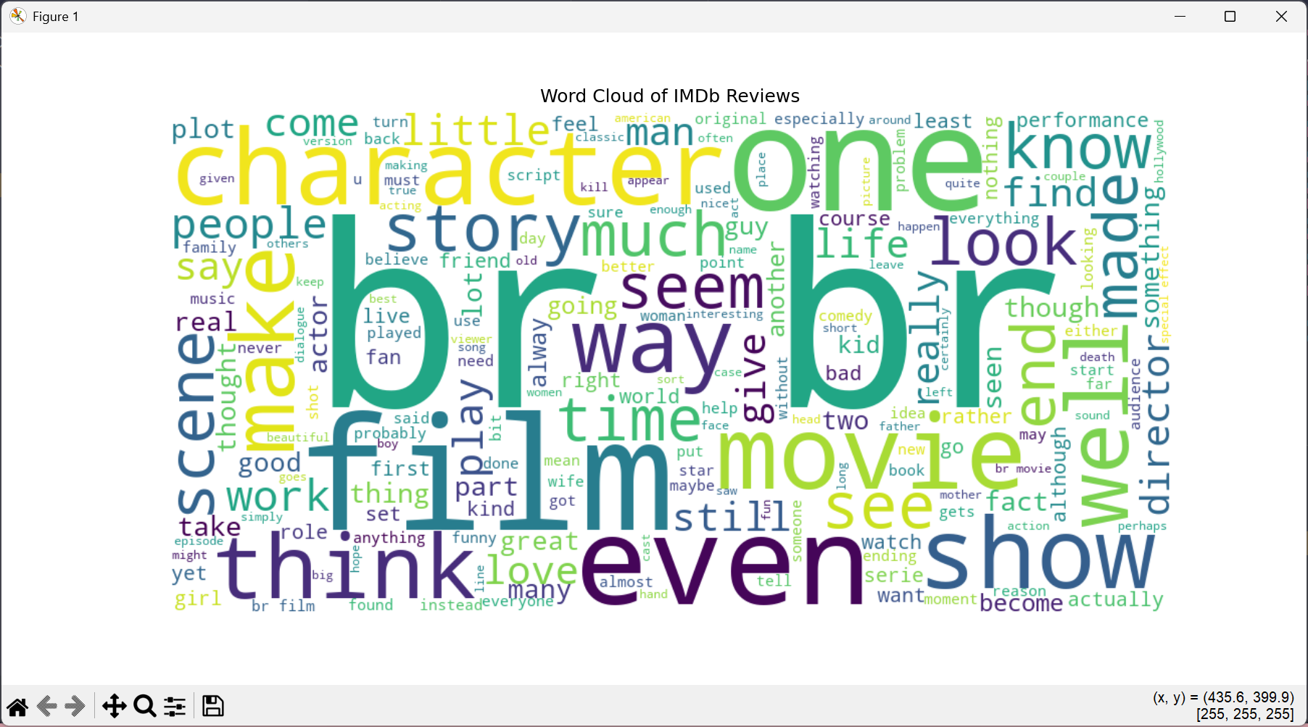

PART C – IMAGE DATA
Using the image dataset:
1. Load an image.
2. Display the image.
3. Determine image dimensions.
4. Determine whether it is grayscale or RGB. Perform conversions
5. Calculate the total number of pixels.

CODE:
import pickle
import numpy as np
import matplotlib.pyplot as plt

def unpickle(file):
with open(file, 'rb') as fo:
data = pickle.load(fo, encoding='bytes')
return data

# 1. Load an Image
batch = unpickle(r"D:\SEM_5\ML\datasets\Image_data\cifar-10-batches-py\data_batch_1")
image = batch[b'data'][0]
image = image.reshape(3, 32, 32)
image = np.transpose(image, (1, 2, 0))

# 2. Display the Image
plt.imshow(image)
plt.title("CIFAR-10 Image")
plt.axis('off')
plt.show()

# 3. Determine Image Dimensions
height, width, channels = image.shape
print("Image Dimensions:")
print("Height =", height)
print("Width =", width)
print("Channels =", channels)

# 4. RGB or Grayscale
if channels == 3:
print("\nImage Type: RGB")
gray = np.mean(image, axis=2)
plt.imshow(gray, cmap='gray')
plt.title("Grayscale Image")
plt.axis('off')
plt.show()
else:
print("\nImage Type: Grayscale")

# 5. Total Number of Pixels
pixels = height * width
print("\nTotal Number of Pixels =", pixels)

OUTPUT:
1.
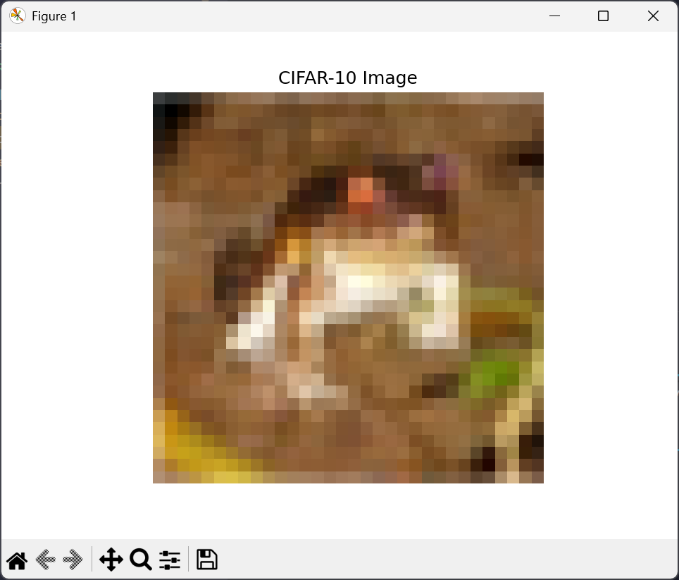
2.
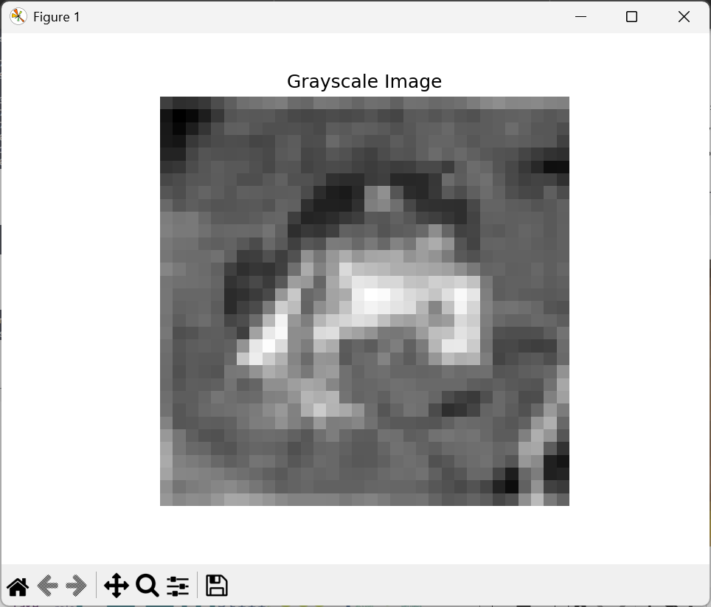

3.
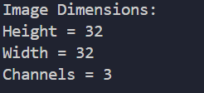

4.

5.

